Date: 5/3/23, 12:00-12:30 pm
Attendees and roles (include building administrator(s):
-
-
Materials:
- Handouts (section of Idaho Special Education Manual, Legal References (from LRP))
- Highlighters
- Technology for creation of shared document
Agenda:
- Debrief situation
  - Did the district….
    - Noncompliance is a reflection on all
    - When we make a mistake, we acknowledge the error, correct, and move on
  - Proof of correction, if needed
    - Letter – explaining correction
    - Determine if team needs to meet to address possible denial of FAPE
    - Meetings – what may need covered (DO NOT Minimize!)

- Idaho Special Education Manual Review (Read together, highlight important points)

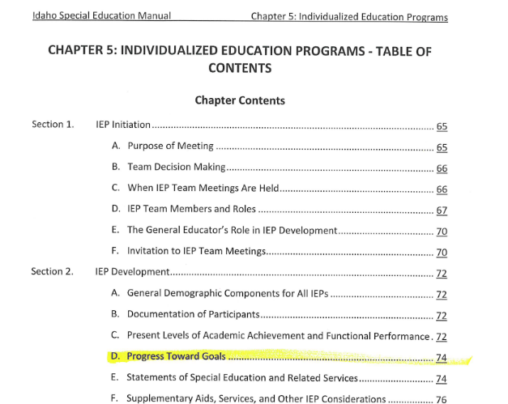

- Review federal law ( LRP Smart Start – IEPs – Measuring Progress)

  - Jigsaw read, Highlight important points
  - Link compliance with district processes
  - 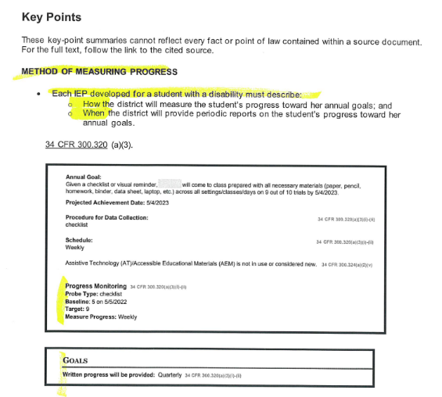

- Review a case study ( LRP article – Don’t Neglect Duty to Share Progress Reports with Parents) (Read silently, highlight important points, share back with group)

- Group summary of importance of progress reporting

- Complete problem solving chart together (so it doesn’t happen again)

Importance of Progress Reporting:
- Progress reports ensure students are making progress in the goal outlined in the IEP
- Make sure your data collection matches the procedure for data collection listed on the IEP
- Parents can participate when they are informed of the progress of their student
- Ensure the goals are measurable
- Progress reports help the educators make decisions whether they need a new goal or not
- Makes sure the student is receiving educational benefit
- All team members can contribute to the data collection ensuring students are progressing across multiple locations
- Also – required by law!

Challenges and Solutions to Progress reporting
CHALLENGE | SOLUTIONS (NOT EXHAUSTIVE)
Time | - Share the workload  - Prioritizing  - Use a work day  - Cover for each other
Lack of data | - Use data system  - Train para to help collect data  - Schedule progress monitoring  - Use observational data  - Print blank progress reports to record
Goal is hard to measure | - Adjust goals  - Create data sheet while writing goal  - Ask for supervisor input  - Ask other schools for examples

